[YOUR
NAME]

<today’s date>

Mrs. & Mrs. Smith
4140 Maple St.
Small Town, CA 90210

Dear Mr. and Mrs. Smith:

Just a note to say I’m sorry your house didn’t sell. Please don’t be too discouraged. As you can see, other homes in the neighborhood are selling and your neighbors are moving. Why not you? Don’t give up just because things didn’t work out the first time. Sometimes it happens. It’s not too late to get it done right. There are plenty of qualified buyers willing to pay a full market value for a nice home like yours. This could be you:
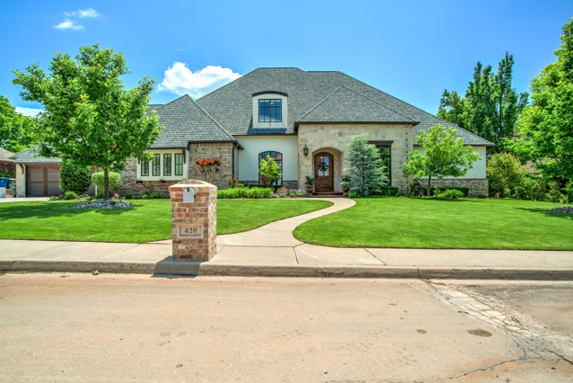
Talk is cheap, I know. You are probably overwhelmed by the calls and letters from all the sales people claiming “I know why your home didn’t sell,” and “I’m a specialist,” or “I have a marketing plan” … and on and on. It can be pretty annoying.
Bottom line: Before you re-list with another agent, have them submit to you legitimate results. In today’s market, the right agent with the right marketing tools and the right attitude makes all the difference.

If you’d like to ask me a few questions—no pressure, no hassle, no obligation—just a friendly conversation about your plans, please give me call.
Sincerely,

[Your Name]
Keller Williams Central Oklahoma
P.S. You can reach me day or night at XXX-XXX-XXXX (cell).

